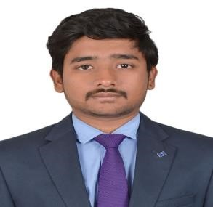

**CONTACT:** Paras tierea, flat no 604, tower 22

**NAME:** Kurapati Sai Krishna Sector-137, Noida.

**BRANCH:** MBA Construction Project Management +91 9182467036

krishnak.mc17n@ricssbe.edu.in

**OBJECTIVE:**

Seeking a position at organization where I can develop and maximize my skills of management, quality

assurance, and training experience



**SKILL SETS:**

•

Team player

•

Decision making

skills

•

Good communication

Skills

•

MS Office

•

AutoCAD

•

MS Project

•

Staad Pro

•

Revit

**CAREER HIGHLIGHTS:**

•

Won the prize for

making both rolling

bridge and ramp pump

technology on

engineers day.



**INTERNSHIP EXPERIENCE:**

**Company:** DE Group

**Period:** May 2018 – July 2018

**Position:** Trainee

**Learnings:** plan execution for the villas as per structural drawings and the problems faced at the site during project.

**Company:** Level Constructions

**Period:** April 16 – May 16

**Position:** Apprentice

**Learnings:** Learning about the construction of trussed structure used for storage facility and construction of partition walls using CLC bricks.



**UNDERGRADUATE PROJECT:**

**Title:** Stabilization of Peat soil using fly ash and gypsum

**Description:** The main objective of the project is to gain the strength, compressibility, and bearing capacity of the soil by mixing the admixtures fly ash and gypsum and also by adding cement to sustain and to increase the bind materials.



**ACADEMIC**

**BACKGROUND:**

Year:

Pursuing

Name:

MBA [CPM]

Body:

RICS SBE, Amity

University

CGPA:

Year:

2013

-

17

Name:

B

-

Tech.

Body:

SCSVMV

University

.

CGPA:

7.09

Year:

2011

-

13

Name:

Intermediate

Body:

Narayana

Junior College

Percentage:

64.1

Year:

2011

Name:

Schooling

Body:

Keshava reddy

. r

esidential School

CGPA:

71.5

%

**DETAILED ACHIEVEMENTS:**

•

Se

cured

second

po

sition at a Dance competition at graduate level

.

•

Member

in

NSS

.

•

C

ultural co

-

ordinator

at graduation level

.

•

State player in Taekwondo.

**PERSONAL INFORMATION:**

•

**Date of Birth:**

18

-

06

-

1996

•

**Father’s Name:**

K Venkatesh Babu

•

**Languages Kno**

**wn:**

English, Hindi, Telugu

,Tamil.

•

**Passport Available:**

Yes

•

**Passport No:**

**R2815268**